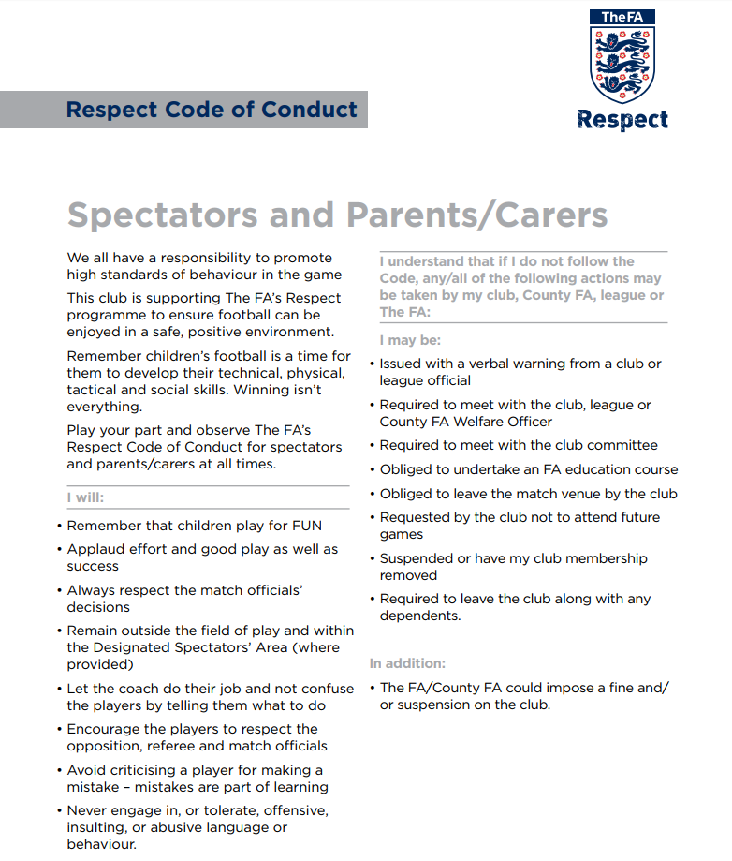
Parent/Guardian/Spectators Signature:
Date:

